**Software testing**

Software testing tutorial provides basic and advanced concepts of software testing. Our software testing tutorial is designed for beginners and professionals.

Software testing is widely used technology because it is compulsory to test each and every software before deployment.

Software testing is a process of identifying the correctness of software by considering its all attributes (Reliability, Scalability, Portability, Re-usability, Usability) and evaluating the execution of software components to find the software bugs or errors or defects.

**Type of Software testing**

We have various types of testing available in the market, which are used to test the application or the software.

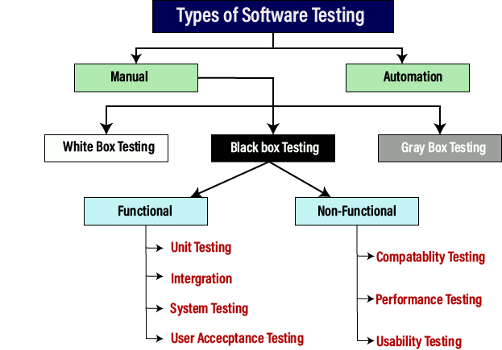With the help of below image, we can easily understand the type of software testing:

the benefits of using software testing:

* **Cost-Effective:**It is one of the important advantages of software testing. Testing any IT project on time helps you to save your money for the long term. In case if the bugs caught in the earlier stage of software testing, it costs less to fix.
* **Security:**It is the most vulnerable and sensitive benefit of software testing. People are looking for trusted products. It helps in removing risks and problems earlier.
* **Product quality:**It is an essential requirement of any software product. Testing ensures a quality product is delivered to customers.
* **Customer Satisfaction:**The main aim of any product is to give satisfaction to their customers. UI/UX Testing ensures the best user experience.

**Quality Assurance in Software Testing** is defined as a procedure to ensure the quality of software products or services provided to the customers by an organization. Quality assurance focuses on Improving the software development process and making it efficient and effective as per the quality standards defined for software products. Quality Assurance is popularly known as QA Testing.

Software Quality Assurance is a process which works parallel to development of software. It focuses on improving the process of development of software so that problems can be prevented before they become a major issue. Software Quality Assurance is a kind of Umbrella activity that is applied throughout the software process.

QA Process steps:

* Plan – Organization should plan and establish the process related objectives and determine the processes that are required to deliver a high-Quality end product.
* Do – Development and testing of Processes and also “do” changes in the processes
* Check – Monitoring of processes, modify the processes, and check whether it meets the predetermined objectives
* Act – A Quality Assurance tester should implement actions that are necessary to achieve improvements in the processes

**Software Quality Assurance has:**

1. A quality management approach
2. Formal technical reviews
3. Multi testing strategy
4. Effective software engineering technology
5. Measurement and reporting mechanism

**Benefits of Software Quality Assurance (SQA):** 

1. SQA produces high quality software.
2. High quality application saves time and cost.
3. SQA is beneficial for better reliability.
4. SQA is beneficial in the condition of no maintenance for a long time.
5. High quality commercial software increase market share of company.
6. Improving the process of creating software.
7. Improves the quality of the software.

**Classification of Performance Testing**

Performance testing includes the various types of testing.

Load Testing

While executing the performance testing, we will apply some load on the particular application to check the application's performance, known as load testing. Here, the load could be less than or equal to the desired load.

It will help us to detect the highest operating volume of the software and bottlenecks.

Scalability Testing

To analysis, the application's performance by enhancing or reducing the load in particular balances is known as scalability testing.

In scalability testing, we can also check the system, processes, or database's ability to meet an upward need. And in this, the Test Cases are designed and implemented efficiently.

Stability Testing

Stability testing is a procedure where we evaluate the application's performance by applying the load for a precise time.

It mainly checks the constancy problems of the application and the efficiency of a developed product. In this type of testing, we can rapidly find the system's defect even in a stressful situation.

**Usability Testing**

Another type of **non-functional testing** is **usability testing**. In usability testing, we will analyze the user-friendliness of an application and detect the bugs in the software's end-user interface.

Here, the term **user-friendliness** defines the following aspects of an application:

* The application should be easy to understand, which means that all the features must be visible to end-users.
* The application's look and feel should be good that means the application should be pleasant looking and make a feel to the end-user to use it.

Integration Testing

Once we are successfully implementing the unit testing. It is the second level of functional testing, where we test the data flow between dependent modules or interface between two features is called **integration testing**.

The purpose of executing the integration testing is to test the statement's accuracy between each module.

Integration testing is also further divided into the following parts:

* Incremental Testing
* Non-Incremental Testing

Another part of **manual testing** is **grey box testing**. It is a **collaboration of black box and white box testing**.

Since, the grey box testing includes access to internal coding for designing test cases. Grey box testing is performed by a person who knows coding as well as testing.

In other words, we can say that if a single-person team done both white box and black-box testing, it is considered grey box testing.

**Automation Testing**

The most significant part of Software testing is Automation testing. It uses specific tools to automate manual design test cases without any human interference.

Automation testing is the best way to enhance the efficiency, productivity, and coverage of Software testing.

It is used to re-run the test scenarios, which were executed manually, quickly, and repeatedly.

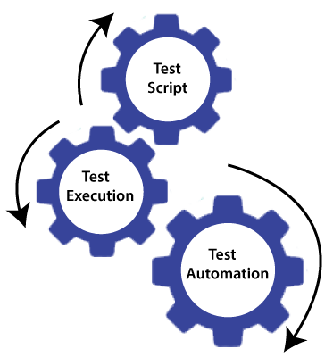

In other words, we can say that whenever we are testing an application by using some tools is known as **automation testing**.

We will go for automation testing when various releases or several regression cycles goes on the application or software. We cannot write the test script or perform the automation testing without understanding the programming language.

security testing?

Security testing is an integral part of software testing, which is used to discover the weaknesses, risks, or threats in the software application and also help us to stop the nasty attack from the outsiders and make sure the security of our software applications.

The primary objective of security testing is to find all the potential ambiguities and vulnerabilities of the application so that the software does not stop working. If we perform security testing, then it helps us to identify all the possible security threats and also help the programmer to fix those errors.

**Bug in Software Testing**

The Bug is the informal name of defects, which means that software or application is not working as per the requirement. a software bug can also be issue, error, fault, or failure. The bug occurred when developers made any mistake or error while developing the product.

**Jira**

Jira is one of the most important bug tracking tools. Jira is an open-source tool that is used for bug tracking and project management.

Jira includes different features like reporting, recording, and workflow. In Jira, we can track all kinds of bugs and issues, which are related to the software and generated by the test engineer.

As soon as the test engineer finds the bug, status is given as New, which indicates that a bug is just found.

This new bug needs to be reported to the concerned Developer by changing the status as **Assigned** so that the responsible person should take care of the bug.

Then the Developer first go through the bug, which means that the Developers read all the navigation steps to decide whether it is a valid bug or not.

Based on this, if the bug is valid, the Developer starts reproducing the bug on the application, once the bug is successfully reproduced, the Developer will analyze the code and does the necessary changes, and change the status as **Fixed**.

Once the code changes are done, and the bug is fixed, the test engineer re-test the bug, which means that the test engineer performs the same action once again, which is mentioned in the bug report, and changes the status accordingly:

**Close**, if the bug fixes properly, and functionally working according to the requirement.

**OR**

**Re-open**, if the bug still exists or not working properly as per the requirement, then the bug sends it back to the Developer once again.